5.4 Snippet Generator

This section will guide you to:
- Generate a step snippet with the Snippet Generator
Please Note: This demo is incremental. Ensure you have completed the earlier demos.

This lab has one sub-section, namely:
5.4.1 Generating Pipeline code with Snippet Generator

Step 5.4.1: Generating Pipeline code with Snippet Generator
- Navigate to the Pipeline Syntax link (referenced below) from a configured Pipeline, or at ${YOUR_JENKINS_URL}/pipeline-syntax.
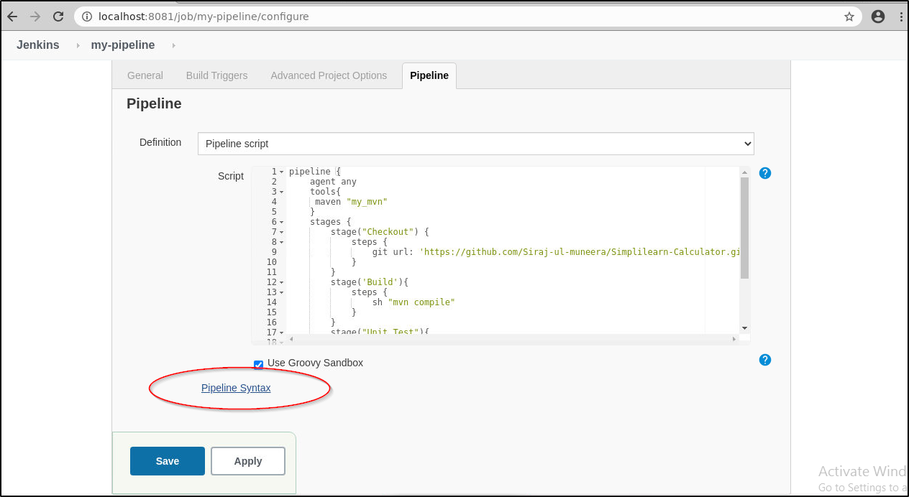
- Select the desired step in the Sample Step dropdown menu
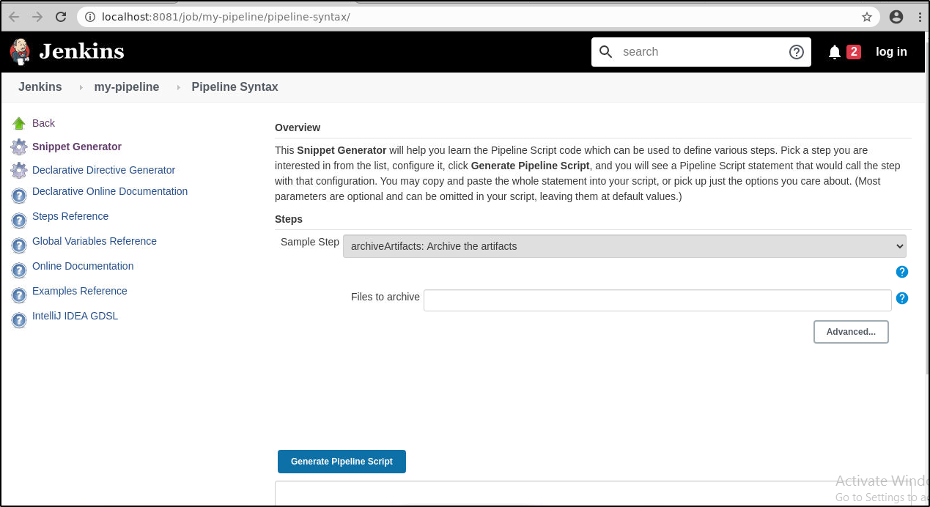
- Use the dynamically populated area below the Sample Step dropdown to configure the selected step.
- Click Generate Pipeline Script to create a snippet of Pipeline which can be copied and pasted into a Pipeline.
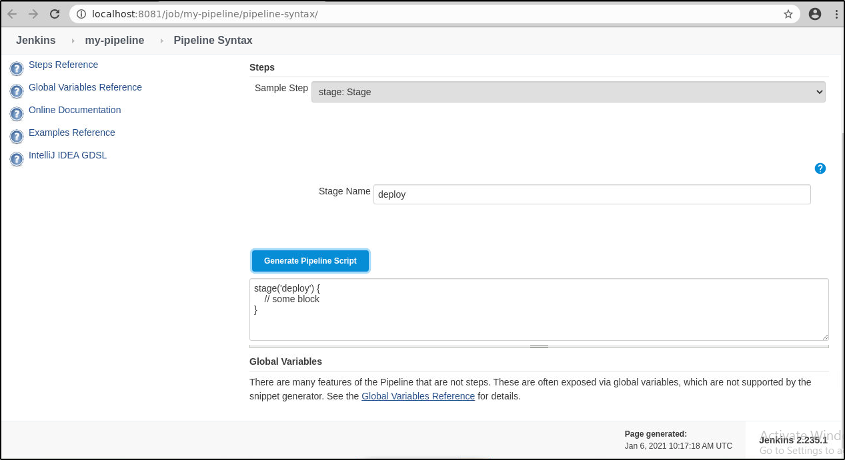
- To access additional information and/or documentation about the step selected, click on the help icon (question mark icon in blue).

